# DAB Trial

## Basic tutorial for research coordinators

* Open a browser.  
   Ideally this should be the most up to date browser available.  
  Internet Explorer (IE) 9 and 10 work well, IE 7 & 8 OK and IE 6 barely.   
  All other browsers (Safari, Chrome, Opera and Firefox) work well.
* Type dabtrial.com into the address bar
* Your screen should look like this:  
  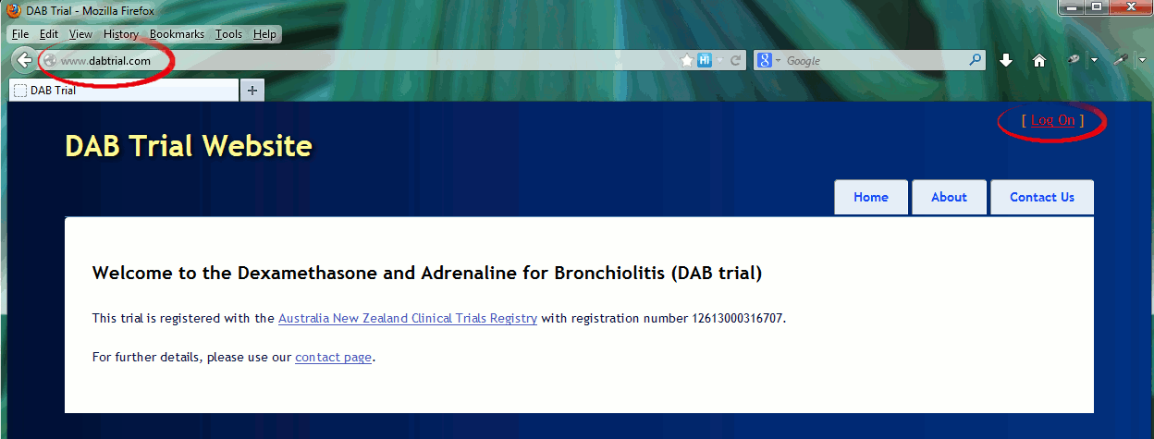  
  Click Log On
* Log on with the user name and password that have been emailed to you (usually your user name will be your first name followed by the first initial of your last name).
* Change the password to one you will remember.   
  *Please note that 1 character must be a non-letter or number, e.g. *+.!  
  Your passwords are encrypted, and so cannot be retrieved. However, if you forget, you may type in your email (link via the log on page) and have a new password sent.
* If you are the first investigator from your site, please ensure the details for your unit are correct by clicking on the ‘Sites’ tab (if you are a principle investigator, all sites will be listed, otherwise you will only see your own site):  
  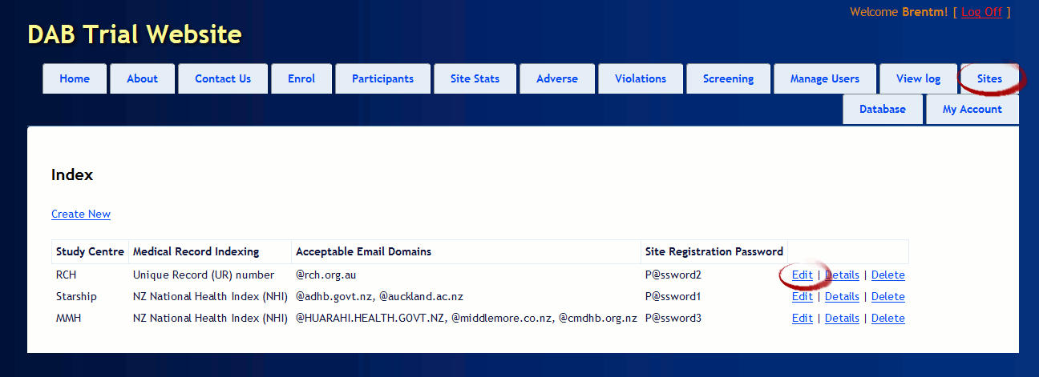  
  Click on the ‘Edit’ link for your site.
* If your site has a default password (usually P@ssword followed by a number), you must change it to something unique. This password is a security vulnerability until changed.  
  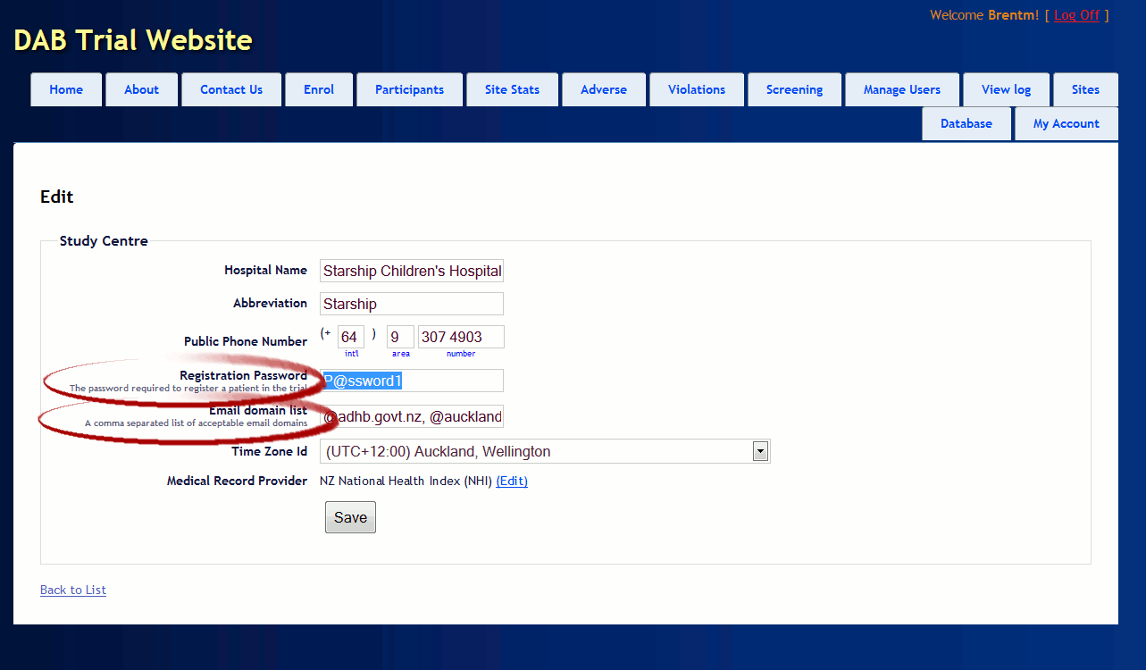  
  Please also check the phone number (this will be available on the internet), and the email domain list. The domain is the part of an email which comes after the @ sign. All domains listed should be associated with the hospital or associated research organisations. Including domains like @gmail.com is a security vulnerability, and should not be done under any circumstances.
* To update patient information, first click on the ‘Participants’ tab  
  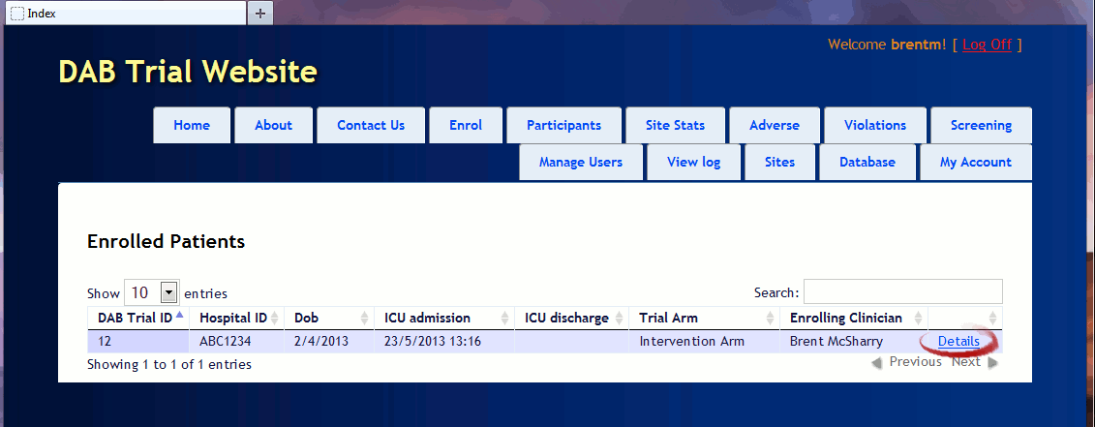  
  Then click on ‘Details’ for the participant you wish to update.  
  *Please note that while the Hospital ID is visible, it is stored in encrypted form and not able to be viewed by users from other hospitals (including the principle investigators, statisticians etc.). The same applies to the screening log.
* This will take you to the window from which you enter all changes about the patient:  
  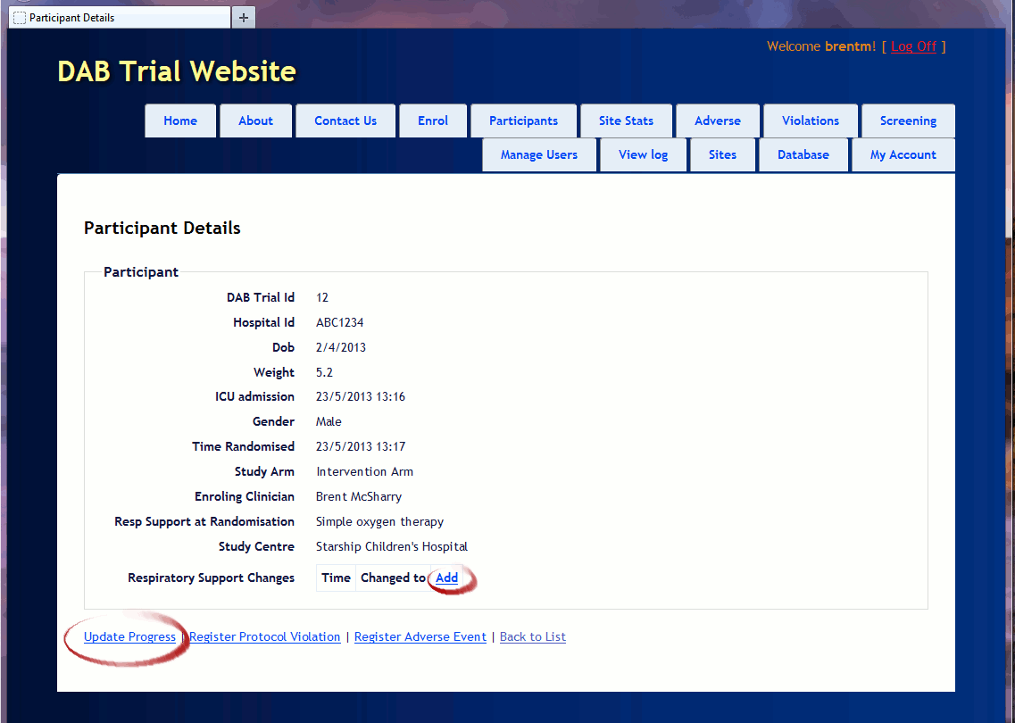  
  Note the various links to entering information about the patient.
* For example, to update details about the patient as new information comes to hand:  
  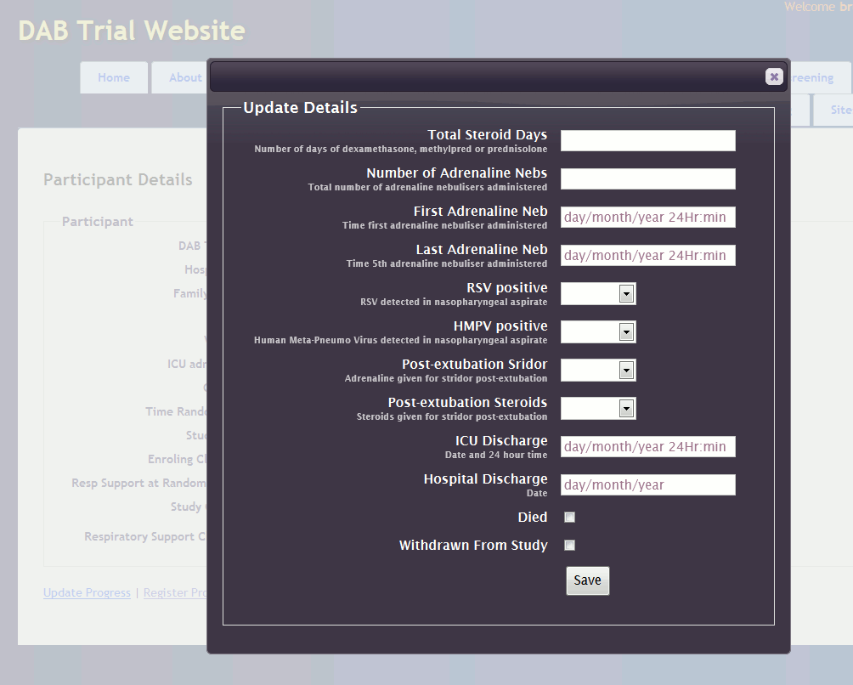
* And to register a change to the respiratory support (click save each time respiratory support is changed):  
  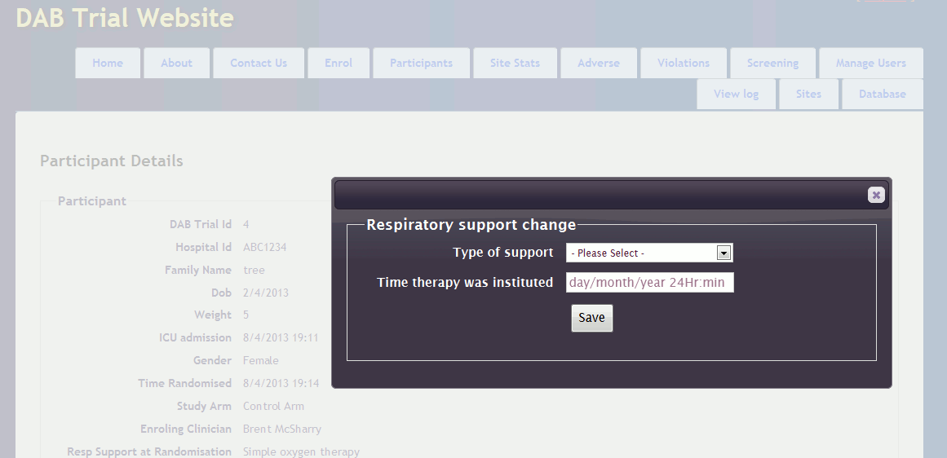And so on for protocol violations and adverse events.
* To update the screening log, click on the tab marked ‘screening’:  
  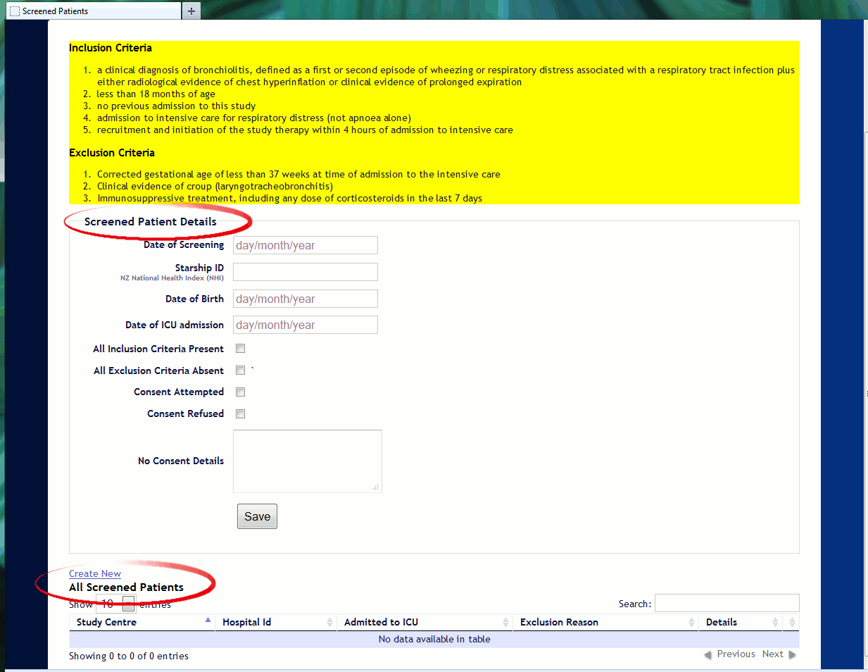  
  A reminder of the inclusion and exclusion criteria is in yellow.  
  The middle of the page is the form for entering or editing data about screened patients.  
  The bottom of the screen allows the screening log to be ordered and searched by various criteria.
* Note that enrolled patients are not considered ‘screened patients’, that is, please do not duplicate data by trying to re-enter enrolled patient data.

Should you experience technical issues to do with the website, please contact Brent McSharry:

* Email [brentm@adhb.govt.nz](mailto:brentm@adhb.govt.nz)
* Via the website (‘Contact Us’ or ‘Manage Users’ pages)
* Mobile (preferred) (+64) 21 245 9769
* or (+64) 9 367 0000 (ext 25224)

Brent can be contacted 24/7 in order to enrol a patient if technical issues are preventing randomisation. For other issues, Brent is contactable 8am to 6pm (New Zealand time).

Suggestions for how to improve the website or feedback on features which are slow or confusing is much appreciated.